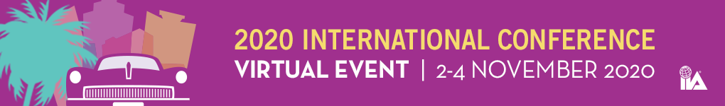

FAQs

How many CPEs can I earn up to?
18 CPES

What time zone will the event be broadcasted in?
Eastern Standard Time

What happens if I miss a session? Will I be able to go back and watch for credit?
Select sessions will be available to watch through our playback feature. Playbacks will be available only for paid attendees to view sessions that they have missed for a limited amount of time. Playbacks will not be eligible for NASBA CPE credit. No CPE credits will be awarded retroactively for playbacks previously watched. If you already received credit for a session by attending the live session, you will ineligible for additional credit. You will cannot claim more than 18 total CPEs for the 2020 International Conference.

Will live sessions be translated?
Yes. Using artificial intelligence, we will be providing simultaneous translation in 16 languages.
Languages include:
Arabic | Bengali | Chinese (simplified) | Chinese (traditional) | Dutch | English | French
German | Hindi | Italian | Japanese | Korean | Portuguese | Russian | Spanish | Tamil

Will playbacks have translation available?
No, unfortunately translation will only be available for live broadcasted sessions.

Will there be OnDemand available?
OnDemand will be available at a later date for purchase. Select sessions will be available for OnDemand. Translation will not be available for sessions OnDemand.

What are the system requirements?
Check your setup by going to: https://onlinexperiences.com/launch/StudioTest.htm
Once you have run this test, please close this window.

What browser should I use?
Please use Chrome or Firefox. Please click below for additional details
https://presentations.akamaized.net/ProductResources/Production/HTML/ComputerTips/ComputerTips.html

